Our Vision

The Colchester Community United Methodist Church, through God’s grace, strives to be a loving, nurturing, and hope-filled community of faith dedicated to raising up a new generation of Christian disciples to be in mission with us and the Holy Spirit for the transformation of our community and the world.

Our Mission

To serve God, our community, and our world, sharing the grace of Jesus Christ
Meet Our Pastor
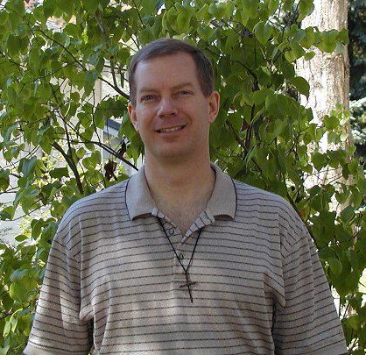

Pastor Dale Ashby

Contact Us:

Phone:

(607)363-2362

Mail:

Colchester Community
United Methodist Church
PO Box 305
Downsville, NY 13755

Email:

Southerndelawarecharge @
catskill.net

Website:

http://www.gbgm-umc.org/
Southern_delaware_charge

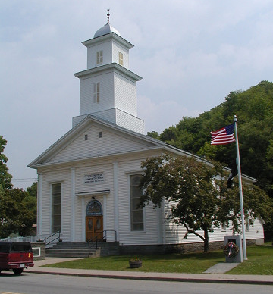
Colchester Community United Methodist Church



Open Hearts
Open Minds
Open Doors

The People of The
United Methodist Church
Our Schedule

Choir Rehearsal
Sunday, 8:45 a.m.

Sunday Worship Service
Sunday, 9:15 a.m.

Sunday School, Grades K-6
Sunday, 10:45 a.m.

Release Time, Grades 1-4
Monday, 11:15 a.m.

Adult Bible Study
Wednesday, 7:00 p.m.

Vacation Bible School
July

AA Meeting
Sunday evening at 7:00 p.m.
Our Ministries

Sunday Choir

Sunday School

Hand-bell Choir

Adult Bible Study

Prayer Shawl Ministry

Hello In There Phone Ministry

Youth Group
Grades 7-12

Vacation Bible School

Helping Honduras Kids Mission Work

Flood Relief and Recovery Work in the community
There are no strangers…
Only friends we have not met yet…

Colchester Community United Methodist Church is located in the beautiful Catskill Mountains of New York. We are on State Route 30 in downtown Downsville, across from the Downsville Fire Department.

If you are new to the area or are looking for a new church family, we hope you will consider joining us for worship and fellowship. We would love to make your acquaintance.

